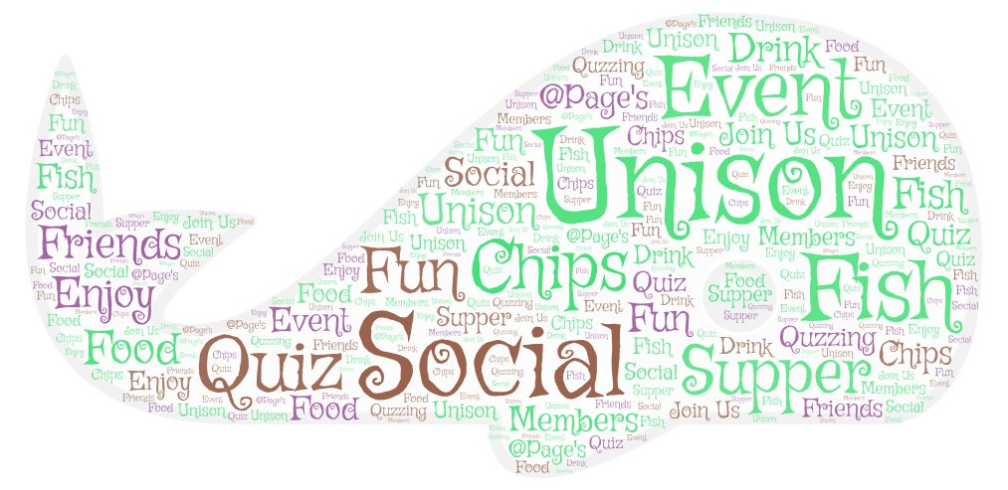

**UNISON’S**

**FISH & CHIPS**

**SUPPER QUIZ NIGHT**

**THURSDAY 29th Nov. 2018**

**at PAGE’S FISH & CHIPS RESTAURANT,**

**CWMBRAN**

**7PM START**



BRING A TEAM (Members & friends) OR JOIN ONE WHEN YOU GET THERE.

TEASE THOSE BRAIN CELLS

AND THOSE TASTE BUDS!

*Raffle in aid of Unison Charity*

*‘There For You’*

TO BOOK A PLACE OR TABLE FOR YOUR TEAM CONTACT KATH BLAKE:-[Unisonblake@yahoo.com](mailto:Unisonblake@yahoo.com)

or text 07969870077 before 28thNov 2018

**Tickets £7:00 per Member / £9:00 Non-members**

**TICKET PRICE INCLUDES FISH & CHIPS.**

[Image result for unison logo wales](http://www.google.co.uk/url?sa=i&rct=j&q=&esrc=s&source=images&cd=&ved=0ahUKEwi1ybTDy5HPAhXDthQKHSupA1cQjRwIBw&url=http://www.righttoknowasbestos.org/How-you-can-help/Petition.html&bvm=bv.132653024,d.ZGg&psig=AFQjCNEPabVlF_mWX6dRaCuUSvlxC2Of-g&ust=1474036344717631)Torfaen

Taking Action